ASSIGNMENT-1 DATE:8/7/24

1. Write a program to reverse a word using loop? (Not to use inbuilt functions)

Sample Input:

String: TEMPLE

Sample Output:

Reverse String: ELPMET

CODE:

class main{

public static void main(String[]args){

String original="happy";

String reverse="";

for(int i =original.length()- 1;i>=0;i--)

reverse+=original.charAt(i);

System.out.print(reverse);

}

}

OUTPUT:

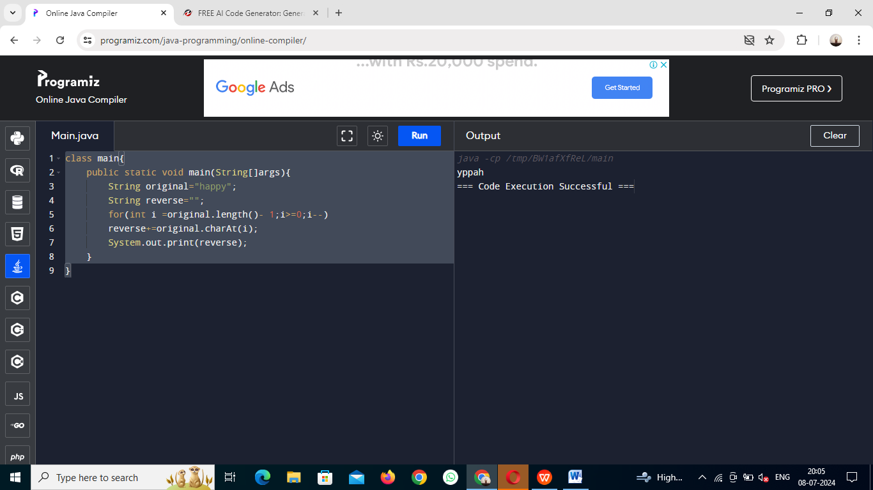

2.Write a program to convent the given string to integer?

Sample Input:

String: 1234

Sample Output:

Out put String: 1234

CODE:

class main{

public static void main(String[]args){

String str="1234";

int num=Integer.parseInt(str);

System.out.print(num);

}

}

OUTPUT:

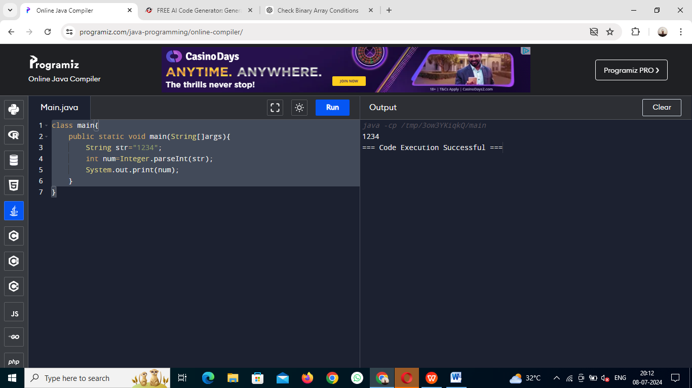

3.Write a program to check the entered user name is valid or not. Get both the inputs from the user.

CODE:

import java.util.Scanner;

class main{

public static void main(String[]args){

Scanner validcheck=new Scanner(System.in);

System.out.print("enter a username:");

String username=validcheck.nextLine();

if (username.matches("^[9-zA-Z0_9-]{3,17}$")){

System.out.print("valid username.");}

else{

System.out.print("not valid username.");}

validcheck.close();

}

}

OUTPUT:

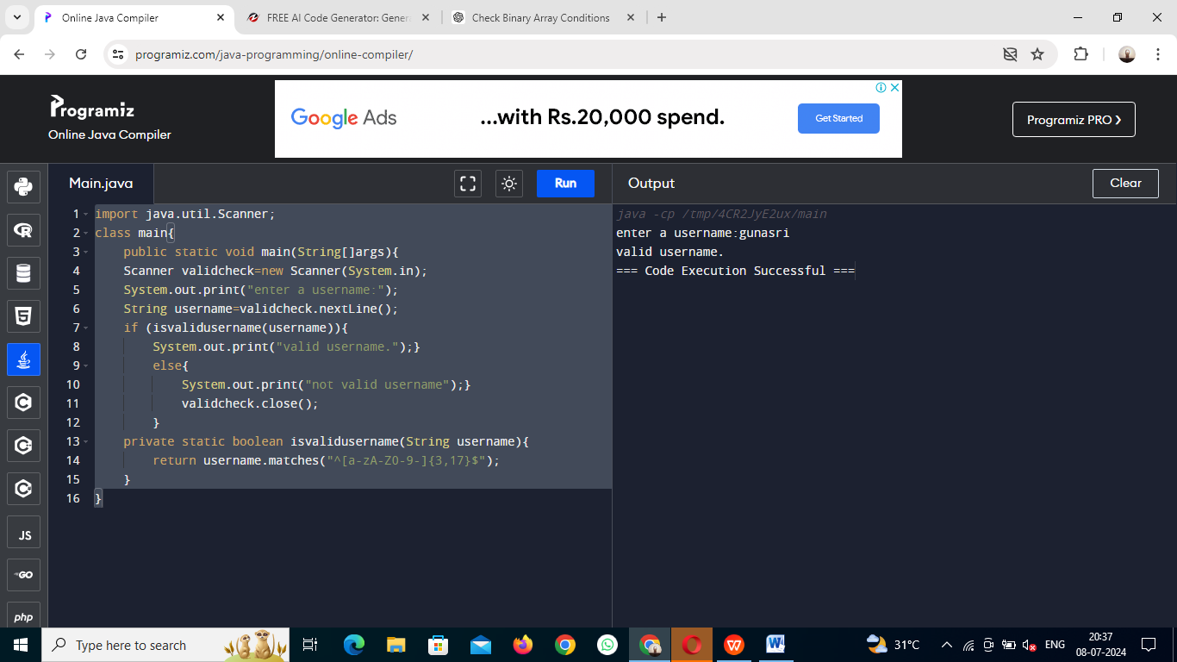

4.Write a program that would sort a list of names in alphabetical order Ascending or Descending, choice get from the user?

Sample Input:

Banana

Carrot

Radish

Apple

Jack

Order(A/D) : A

Sample Output:

Apple

Banana

Carrot

Jack

Radish

CODE:

import java.util.ArrayList;

import java.util.Collections;

import java.util.Scanner;

public class NameSorter {

public static void main(String[] args) {

ArrayList<String> names = new ArrayList<>();

Scanner scanner = new Scanner(System.in);

System.out.println("Enter names (one per line, type 'done' to finish):");

String input;

while (!(input = scanner.nextLine()).equalsIgnoreCase("done")) {

names.add(input);

}

System.out.print("Enter sorting order (A for Ascending, D for Descending): ");

String order = scanner.nextLine();

if (order.equalsIgnoreCase("A")) {

Collections.sort(names);

} else if (order.equalsIgnoreCase("D")) {

Collections.sort(names, Collections.reverseOrder());

}

System.out.println("Sorted Names:");

for (String name : names) {

System.out.println(name);

}

}

}

OUTPUT:

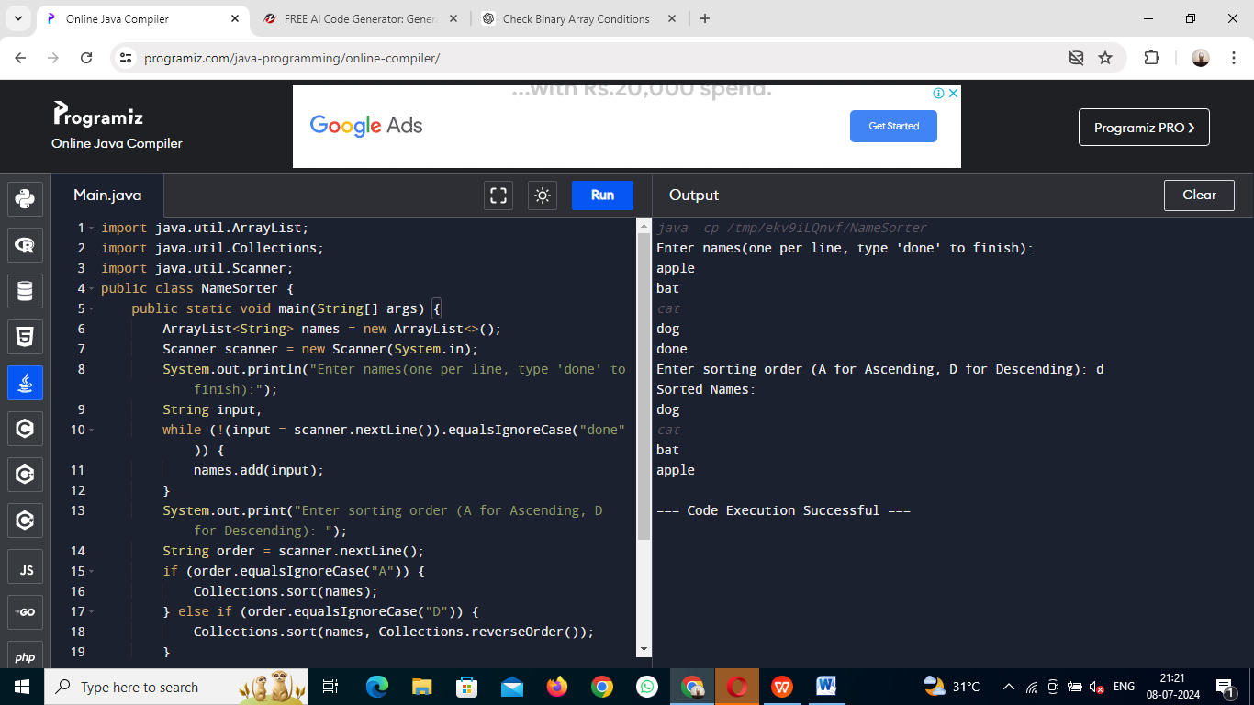

5.Write a program to print the special characters separately and print number of Special characters in the line?

CODE:

public class SpecialCharactersCounter {

public static void main(String[] args) {

String line = "Hello! How are you? 123 #$%";

int specialCharCount = 0;

for (int i = 0; i < line.length(); i++) {

char ch = line.charAt(i);

if (!(Character.isLetterOrDigit(ch) || Character.isWhitespace(ch))) {

System.out.println(ch);

specialCharCount++;

}

}

System.out.println("Number of special characters: " + specialCharCount);

}

}

OUTPUT:

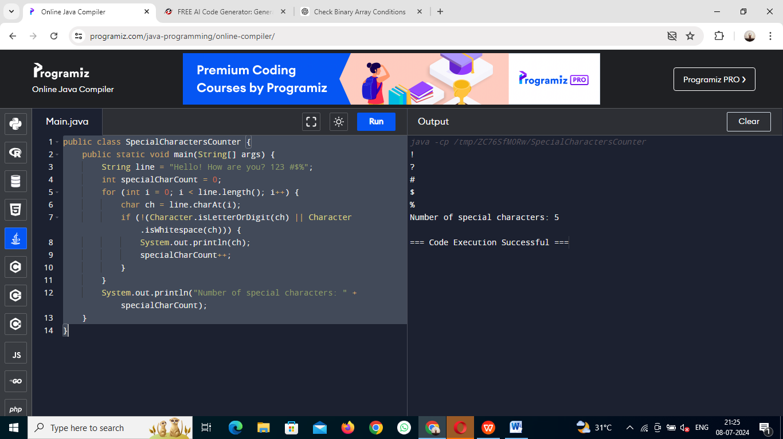

6.Write a program to print the number of vowels in the given statement?

Sample Input:

Saveetha School of Engineering

Sample Output:

Number o vowels = 12

CODE:

public class CountVowels {

public static void main(String[] args) {

String statement="Saveetha School of Engineering";

int vowelsCount=countVowels(statement);

System.out.println("Number of vowels="+vowelsCount);

}

public static int countVowels(String statement) {

int count=0;

for (int i=0;i<statement.length();i++) {

char ch=statement.charAt(i);

if (isVowel(ch)) {

count++;

}

}

return count;

}

public static boolean isVowel(char ch) {

ch = Character.toUpperCase(ch);

return ch=='A'||ch=='E'||ch=='I'||ch=='O'||ch=='U';

}

}

OUTPUT:

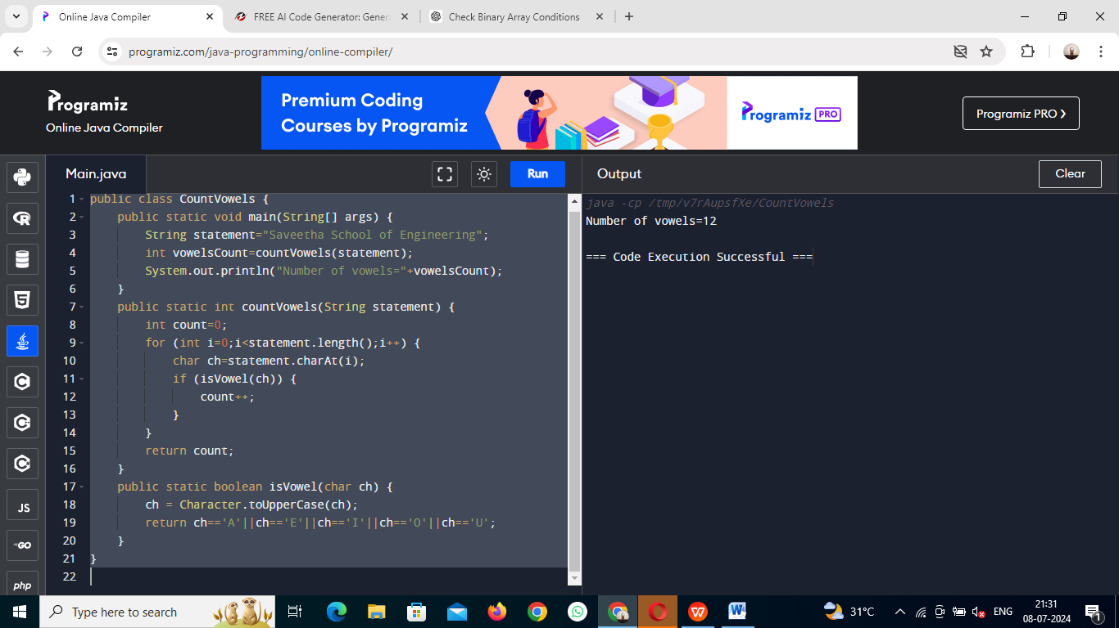

7.Write a program to print consonants and vowels separately in the given word

Sample Input:

Given Word: Engineering

Sample Output:

Consonants: n g n r n g

Vowels: e i e ei

CODE:

public class Main {

public static void main(String[] args) {

String word="Engineering";

word=word.toLowerCase();

String vowels = "aeiou";

String consonants = "";

for (int i = 0; i < word.length(); i++) {

char ch = word.charAt(i);

if (vowels.indexOf(ch) != -1) {

System.out.print(ch+" ");

} else if (Character.isLetter(ch)) {

consonants += ch + " ";

}

}

System.out.println("\nConsonants: " + consonants.trim());

}

}

OUTPUT:

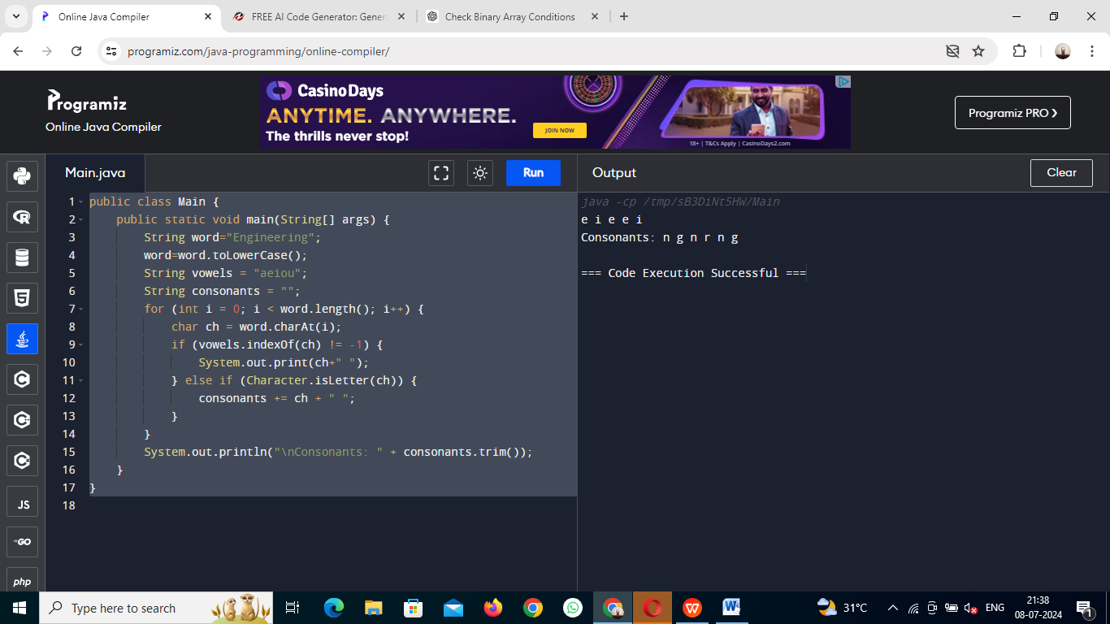

8.Write a program that finds whether a given character is present in a string or not. In case it is present it prints the index at which it is present. Do not use built-in find functions to search the character.

Sample Input:

Enter the string: I am a programmer

Enter the character to be searched: p

Sample Output:

P is found in string at index: 8

Note: Check for non available Character in the given statement as Hidden Test case.

CODE:

import java.util.Scanner;

public class CharacterFinder {

public static void main(String[] args) {

Scanner scanner = new Scanner(System.in);

System.out.print("Enter the string: ");

String inputString = scanner.nextLine();

System.out.print("Enter the character to be searched: ");

char searchChar = scanner.next().charAt(0);

int index = findCharacter(inputString, searchChar);

if (index != -1) {

System.out.println(searchChar + " is found in string at index: " + index);

} else {

System.out.println(searchChar + " is not found in the string.");

}

}

public static int findCharacter(String str, char ch) {

char[] charArray = str.toCharArray();

for (int i = 0; i < charArray.length; i++) {

if (charArray[i] == ch) {

return i;

}

}

return -1;

}

}

OUTPUT:

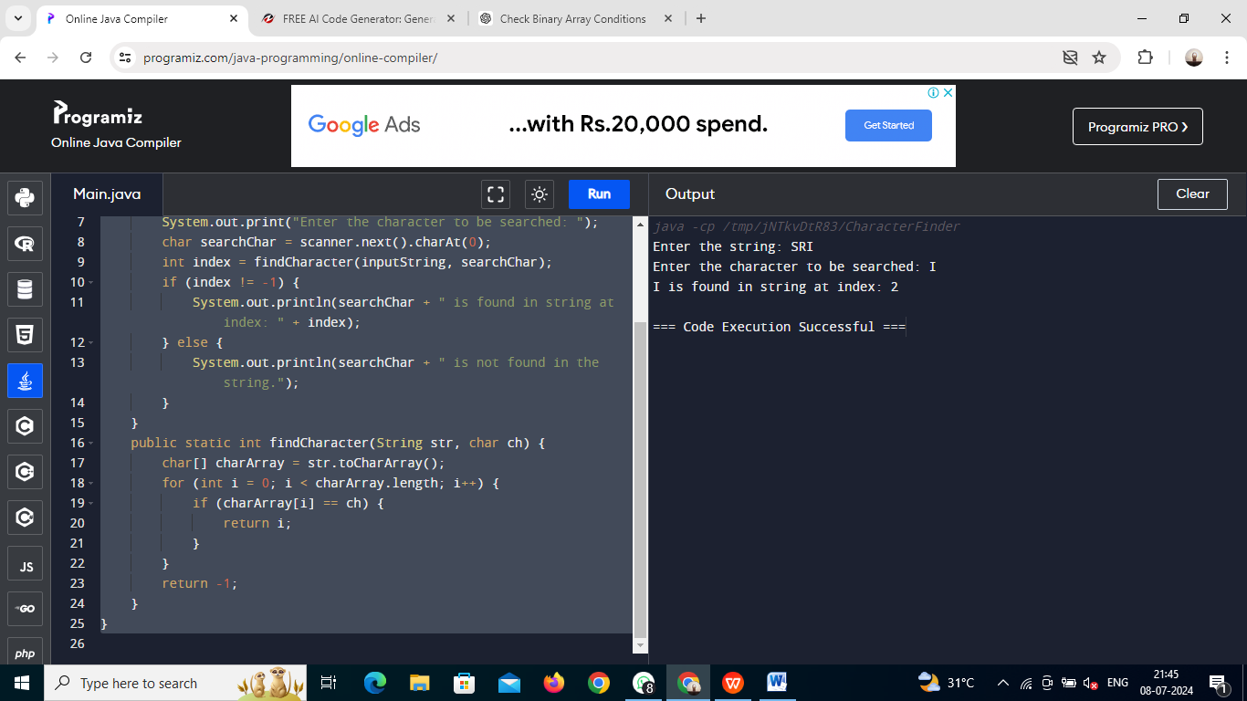

9.Write a program to arrange the letters of the word alphabetically in reverse order

Sample Input:

Enter the word: MOSQUE

Sample Output:

Alphabetical Order: U S Q O M E

CODE:

import java.util.Arrays;

import java.util.Scanner;

public class ReverseAlphabeticalOrder {

public static void main(String[] args) {

Scanner scanner = new Scanner(System.in);

System.out.print("Enter the word: ");

String word = scanner.nextLine();

char[] chars = word.toCharArray();

Arrays.sort(chars);

String sortedWord = new String(chars);

String reverseSortedWord = new StringBuilder(sortedWord).reverse().toString();

System.out.println("Alphabetical Order:"+reverseSortedWord );

}

}

OUTPUT:

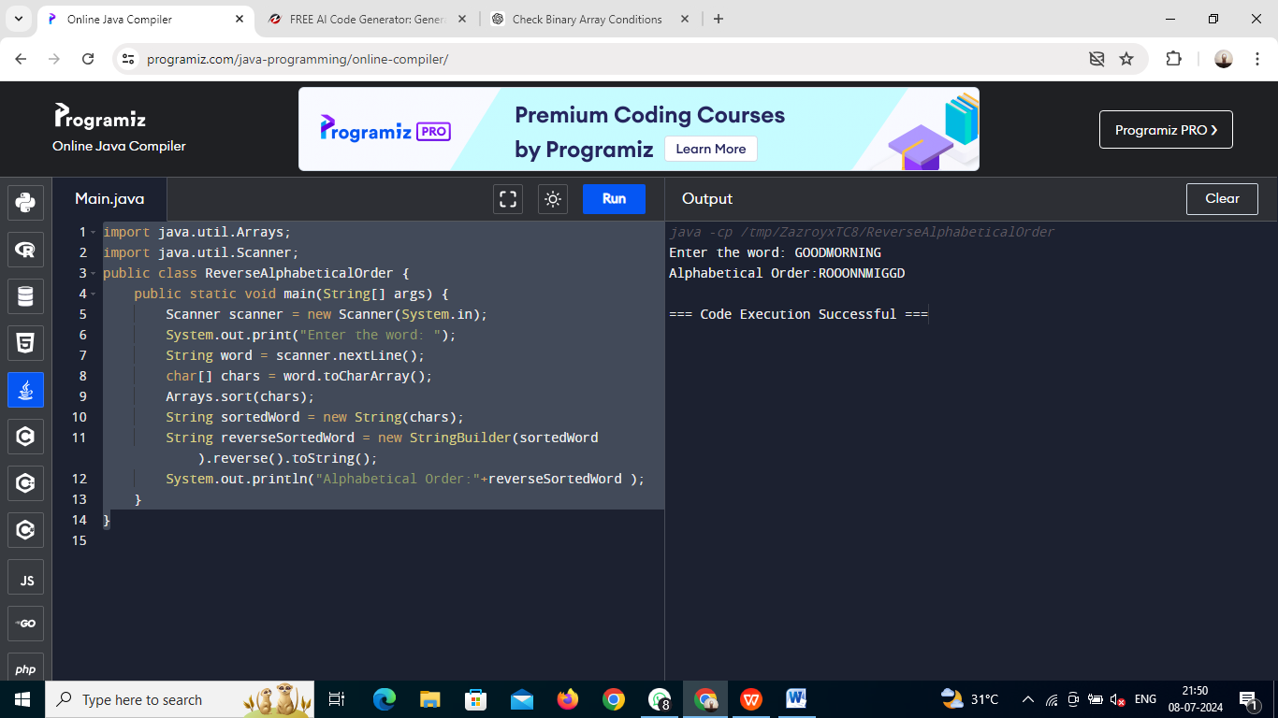

10. Write a program that accepts a string from user and displays the same string after removing vowels from it.

Sample Input & Output:

Enter a string: we can play the game

The string without vowels is: w cn ply thgm

CODE:

import java.util.Scanner;

public class Main {

public static void main(String[] args) {

Scanner scanner = new Scanner(System.in);

System.out.print("Enter a string: ");

String input = scanner.nextLine();

String result = input.replaceAll("[aeiouAEIOU]", "");

System.out.println("The string without vowels is: " + result);

}

}

OUTPUT:

